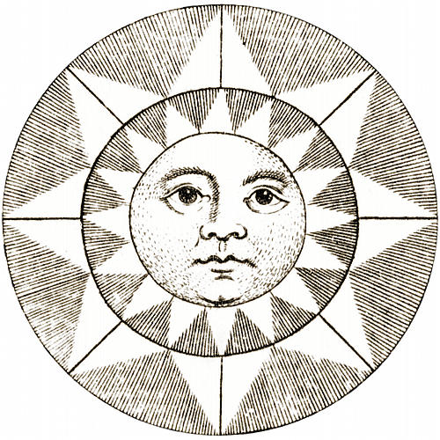

Cult
of the Sun

An expansion for Polaris
by Chris Sakkas

Typeset in Liberation Serif. Art from <http://www.fromoldbooks.org/>
“There is no thing mightier upon the sky or upon the ice.”

Were the Stellar Knights to ever halt their southward gaze, to stare inwards and reflect, they may find their loneliness eased. They are not the only ones who recognise the tremendous threat posed by the Mistake, nor the only ones whose doom is tied irrevocably to that festering pit. There are others, bound not to blinking stars but to that immortal engine the Sun.
These Illuminated Monks operate in secret, for knight and mistaken alike would destroy them if given the opportunity. The Cult of the Sun, founded by that unlucky King so long ago, is a mystery cult devoted to research, fierce progress and the destruction of demonkind by fire. The Illuminated welcome the ever-rising Sun, and long for it to reach its zenith. Indeed, they track the approach of this faithful day on a vast Calendar. Ugly? Nay, it whirs a symphony of brass gears and gently daubs grey smoke against the unrelenting sky.

Illuminated Monks have the following three aspects automatically, instead of those granted to Stellar Knights.

Acolyte of the Cult of the Sun
Description: The character is an Illuminated Monk, unraveling mysteries by the light of the Sun.
How it Might Aid You: You call in a favour from a fellow cultist. You research from the cult’s deep vaults. You are performing some action characteristic of monks and the Cult.
How it Might Hinder You: Your actions compromise a fellow monk. The Cult’s secretive nature draws suspicion. The actions of some monks reflect poorly upon you. You learn something you were not meant to know.
Special Rules: Automatic aspect for Illuminated Monks.

Golden Compass
Description: You carry a gilt pocketwatch, gently filigreed, with your name etched upon its cover. A clasp, sometimes locked, triggers its opening.
How it Might Aid You: You need to find your way through the wastes. You need to know the future passage of constellations and of the Sun. It chirps when a demon nears.
How it Might Hinder You: Its presence reveals your membership in the Cult. You lose it. Its glint attracts the attention of something that you would rather avoid.
Special Rules: Automatic aspect for Illuminated Monks.

Lore of the People
Description: You know intimately the cultural practices and customs of the people, and how to use them to your own ends.
How it Might Aid You: You impress others with your culture. You know the history of a remnant, and its secret places. You perform a great work.
How it Might Hinder You: Your lore is false. You become obsessed with people.
Special Rules: Automatic aspect for Illuminated Monks.

